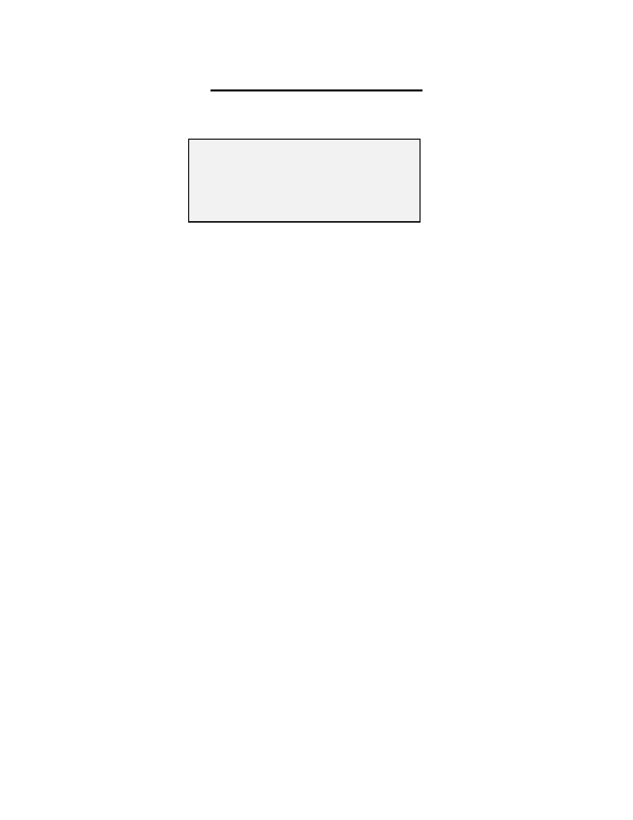

**Form A-I**

**Guidelines for using EPI forms**

**Stock Issue & Receipt Voucher for Routine Immunization**

Note: *This form shall replace the old forms*

A - Stock receipt voucher from Suppliers

B - Stock receipt voucher from Warehouse

C - Stock issuance voucher

**From**  **/ User**  Federal / Provincial / District EPI Stores

**T o / For**  Provincial / Divisional / District EPI Stores

**Timeline**  As and when required

**Step by step procedure**

A. This form is to be filled by federal / provincial / district EPI store incharge for issue / dispatch of

vaccine to next level.

B. Form contains 3 carbonized copies of white yellow and blue colours.

1) 2) 3) 4) 5) 6) 7) 8) 9)

10) 11)

12) 13) 14) 15) 16)

Write issuing store name in the space "Supply from" Write receiving store name in the space "Issued to"

Write date of issue / dispatch

Columns B to H should be filled by issuing store (federal / provincial). Enter manufacturer's name in column 'B'. Enter batch / lot number in column 'C'.

Use blank rows in case of more than one batch of same vaccine

Enter expiry date for each batch in column 'D' as (MM / YY)

Write unit cost in US dollars in column 'E'

Enter quantity issued as number of vials / syringes / safety boxes in column 'F'

Enter quantity issued as number of vaccine doses in column 'G'. To calculate multiply number of doses per vial given in column 'A' with number of vials issued in column 'F'. Write VVM (vaccine vial monitor) stage 1 or 2 in column 'H'.

Enter name & designation of person issuing the stock

Write name of the issuing warehouse Sign the form.

Keep one copy for record and send two copies with the stock to receiving store

C. Columns I to K will be filled by the receiving store incharge (provincial / district).

1) Enter quantity received as number of vials / syringes / safety boxes in column 'I'

2) Enter quantity received as number of vaccine doses in column 'J'. To calculate multiply number of

doses per vial given in column 'A' with number of vials received in column 'I'. 3) Write VVM (vaccine vial monitor) stage 1 or 2 in column 'K'.

4) Enter name & designation of person receiving the stock

5) Write name of the receiving warehouse 6) Sign the form.

7) Keep one copy for record and send one copy back to the issuing store

**Form A-II**  **Stock Issue & Receipt Voucher for SIAs**



Note: *This form shall replace the old forms*

B - Stock receipt voucher from Warehouse

C - Stock issuance voucher

**From**  **/ User**  District & Sub-district EPI Stores

**T o / For**  Tehsil / Union Council / Health Facility

**Timeline**  As and when required

**Step by step procedure**

A. This form is to be filled by divisional / district EPI store incharge for issue / dispatch of vaccine to next

level.

B. Form contains 3 carbonized copies of white yellow and blue colours.

1) 2) 3) 4) 5) 6) 7) 8) 9)

10)

11) 12) 13) 14) 15)

Write issuing store name in the space "Supply from" Write receiving store name in the space "Issued to"

Write date of issue / dispatch

Columns B to G should be filled by issuing store. Enter manufacturer's name in column 'B'. Enter batch / lot number in column 'C'.

Use blank rows in case of more than one batch of same vaccine

Enter expiry date for each batch in column 'D' as (MM / YY)

Enter quantity issued as number of vials / syringes / safety boxes in column 'E'

Enter quantity issued as number of vaccine doses in column 'F'. To calculate multiply number of doses per vial given in column 'A' with number of vials issued in column 'E'. Write VVM (vaccine vial monitor) stage 1 or 2 in column 'G'.

Enter name & designation of person issuing the stock

Write name of the issuing warehouse Sign the form.

Keep one copy for record and send two copies with the stock to receiving store

C. Columns H to J will be filled by the receiving store incharge (tehsil / UC / health facility).

1) Enter quantity received as number of vials / syringes / safety boxes in column 'H'

2) Enter quantity received as number of vaccine doses in column 'I'. To calculate multiply number of

doses per vial given in column 'A' with number of vials received in column 'H'. 3) Write VVM (vaccine vial monitor) stage 1 or 2 in column 'J'.

4) Enter name & designation of person receiving the stock

5) Write name of the receiving warehouse 6) Sign the form.

7) Keep one copy for record and send one copy back to the issuing store

**For m B**

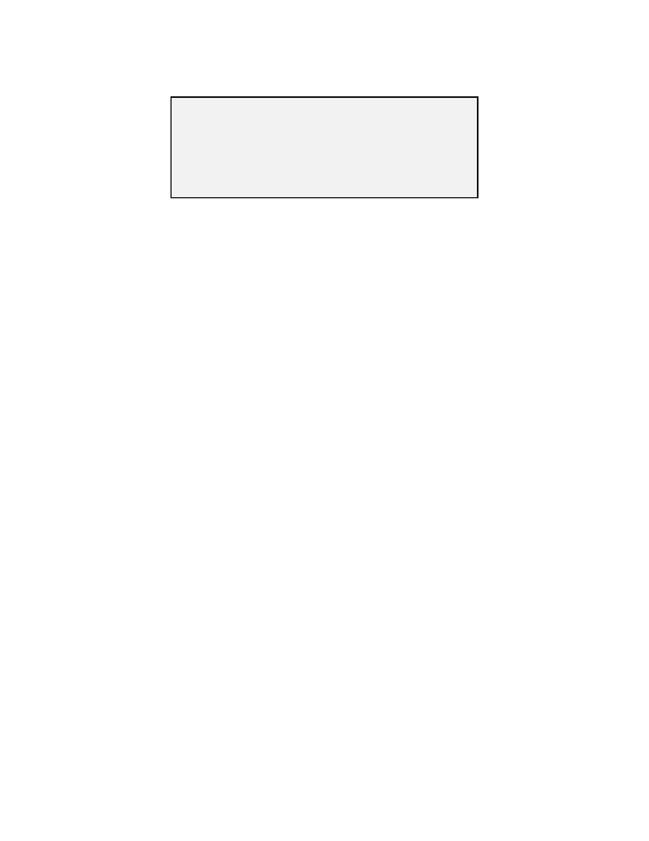

**Consumption & Requisition Form for Routine Immunization**

Note: *This form shall replace the old forms*

D - Monthly consumption reporting form (EPI center)

E - Provincial Vaccine Requisition Form

F - Divisional/District/Sub-District Vaccine Requisition Form

G - Union Council (EPI Center) Vaccine Requisition Form

**From**  **/ User**  Health Facility / Union Council / Tehsil

**T o / For**  District / Divisional / Provincial EPI centers

**Timeline**  Monthly

**Step by step procedure**

A. This form is to be filled by health facility / UC, district / division and provincial EPI centers as monthly

consumption report and requisition for next month.

B. Form contains 3 carbonized copies of white yellow and blue colours. C. EPI center will send the report & requisition to the respective district.

D. District EPI Center will compile the reports of all its EPI centers in to one Form B and send the

consumption & requisition report by 10th of every month to the respective provincial EPI center.

E. Provincial EPI centers will compile all the reports of respective districts/divisions into one form and

send the monthly consumption & requisition report to federal EPI cell

1) 2) 3) 4) 5) 6) 7) 8) 9)

10)

11) 12)

13)

14) 15) 16)

Write health facility / store name , UC, Tehsil/Taluka, District, Province names

Write month and year of the consumption report

In case of District Report, write the district and province name

The reporting center will fill in columns B to I

Column 'J' will be filled by the respective stock issuing EPI store

Enter number of doses available at the center on 1st of the month in column 'B'

Enter number of doses received during the month in column 'C'

Enter number of doses administered during the month in column 'D'

Enter number of vials used during the month in column 'E'

Enter number of unusable vials (expired, damaged due to any reason) during the month in

column 'F'

Enter actual balance of vaccine vials at the end of reporting month in column 'G'

Enter maximum stock level (number of vials)for the respective facility. Should be equal to 2

months requirement for Districts / Health facility and 6 months for province

Enter number of vaccine vials required for the next month. This will be equal to number of vials in column H minus number of vials in column G.

Write name and designation of person completing the form, sign and enter the date

Keep one copy for record and send two copies to the respective district / province

The respective province / district will fill in column 'J' and enter the number of vials issued to the

respective district / EPI center

**For m C**



**Demand, Consumption & Requisition Form for SIAs**

Note: *This form shall replace the old forms*

D - Monthly consumption reporting form (EPI center)

E - Provincial Vaccine Requisition Form

F - Divisional/District/Sub-District Vaccine Requisition Form

G - Union Council (EPI Center) Vaccine Requisition Form

**From**  **/ User**  Health Facility / Union Council / Tehsil

**T o / For**  District / Divisional / Provincial EPI centers

**Timeline**  Requisition 2 weeks before SIA. Report within one week of SIA

**Step by step procedure**

A. This form is to be filled by health facility / UC, district / division and provincial EPI centers as

consumption report for every SIA.

B. Form contains 3 carbonized copies of white yellow and blue colours.

C. EPI center will send the requisition to the respective district / province by filling the columns B to G at

least 2 weeks before the SIA.

D. EPI center will complete the form by filling in columns H to L and send it to the respective district /

province within one week of the completion of SIA

E. District EPI Center will compile the reports of all its EPI centers in to one Form C and send the report

to the respective provincial EPI center.

F. Provincial EPI centers will compile all the reports of respective districts/divisions into one form and

send the report to federal EPI cell

1) 2) 3) 4) 5)

6) 7) 8) 9)

10) 11) 12) 13)

14) 15) 16) 17)

Write health facility / store name , UC, Tehsil/Taluka, District, Province names

Write date month and year of the SIA

In case of District Report, write the district and province name only

Enter the targeted number of children to be vaccinated during the SIA in column 'B'

Enter number of doses required for the target in column 'D' including the wastage by multiplying

number in column B with wastage factor in column C

Enter number of vials required in column 'E' by dividing number of doses in D with A

Enter number of vials available at the center as balance from previous activity in column 'F'

Enter number of vials to be requisitioned in column 'G' by subtracting F from E

Enter number of vials received for the activity from respective district / province in column 'H'

Fill in columns I to L after the activity

Enter number of doses administered during the activity in column 'I'

Enter number of vials used during the activity in column 'J'

Enter number of unusable vials (expired, damaged due to any reason) during the activity in

column 'K'

Enter actual balance of vaccine vials at the end of activity in column 'L'

Write name and designation of person completing the form, sign and enter the date

Keep one copy for record and send two copies to the respective district / province

The respective province / district will compile the report and send to the respective provincial /

federal EPI center